**Guided Solution for Tutorial 3**

**Question 6**

1. Convert the three 6  star- connected resistors to delta- connected resistors.



2. Draw the circuit diagram with the delta-connected resistors.

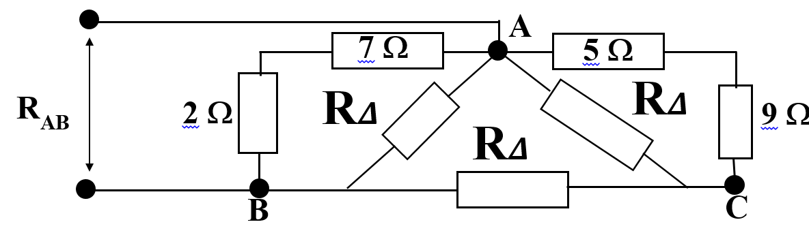

3. Simplify the circuit by doing the obvious first. 5   and 9  are connected in series. R1 is the resultant. 7   and 2  are connected in series and R2 is the resultant.

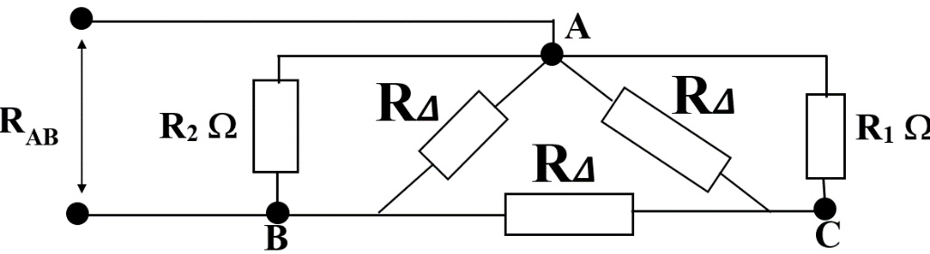4.

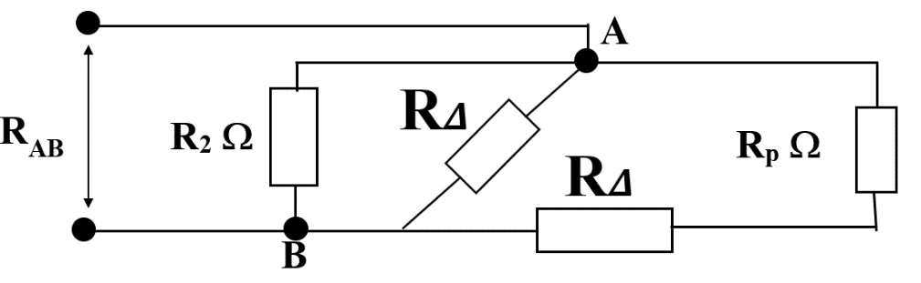5. R1//R∆ = Rp

6. Rp in series with R∆.. R is the resultant.

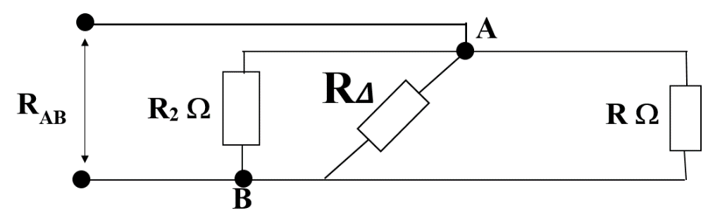

7. RAB = R2// R∆//R